Arrays to String

.toString()

.join()

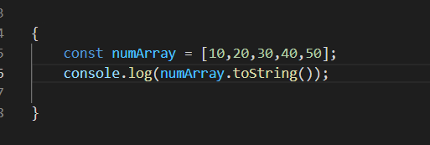

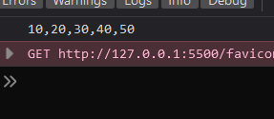

toString() isn’t mostly used in arrays, since it also includes the ,

Basically it converts whatever content supplied to string

It is useful for other things like, dates

In Arrays we use

.join()

1. .join(“”)

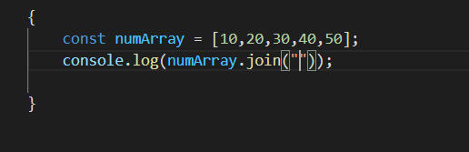

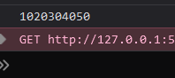

supplying “” as separator

1. .join(“ ”)

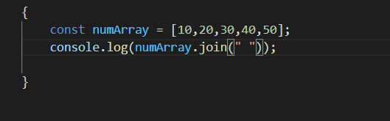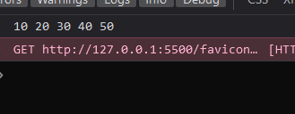

“ ” a space as a separator

1. .join(“*”)

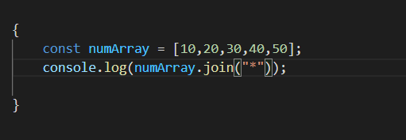

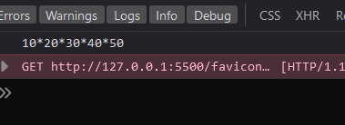

astric as separator

**String to Array**

Very handy and Very Important method

.split ( )

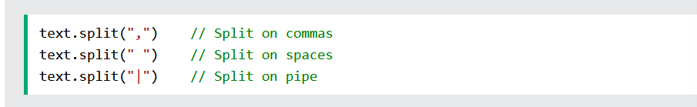

See below

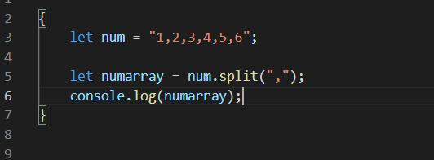



But the numbers still remains string type not Number type

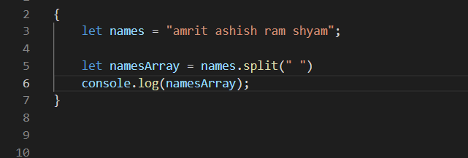

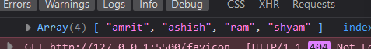

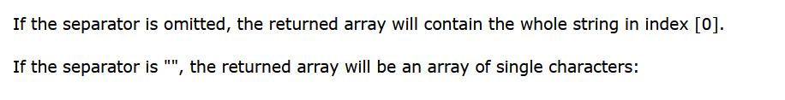

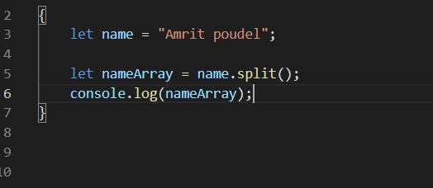

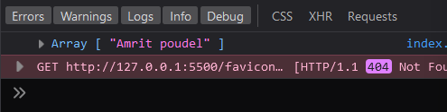

See the whole string gets inside o’th index of the array

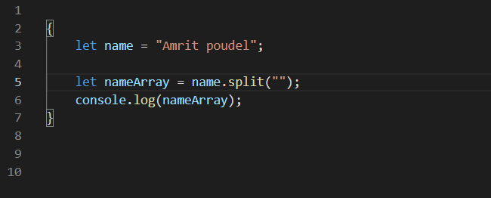

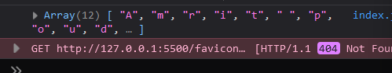

passing .split(“”) will give us array where each letter is the item of that array